Pilot Test Guide

Test Cases:

The request should specify the account id. 1

- The request can specify from date and to date (the date range). 1

- The request can specify from amount and to amount (the amount range). 1

- If the request does not specify any parameter then the search will return three months back statement. 1

- If the parameters are invalid a proper error message should be sent to user. 1

- The account number should be hashed before sent to the user. 1

- All the exceptions should be handled on the server properly. 1

We want to add login and session management functionality. 1

The ‘testadmin’ user is able to perform all the requests (specify date and amount range). 1

- The ‘testUser’ can only do a request without parameters which will return the three months back statement. 1

- When the test user tries to specify any parameter, then HTTP unauthorized access error will be sent. 1

- The user cannot login twice (the user should logout before login). 1

- The session time out is 5 minutes. 1

## 

## - We want to add login and session management functionality.

Case 1: user login will prevent if has such kinds of errors.

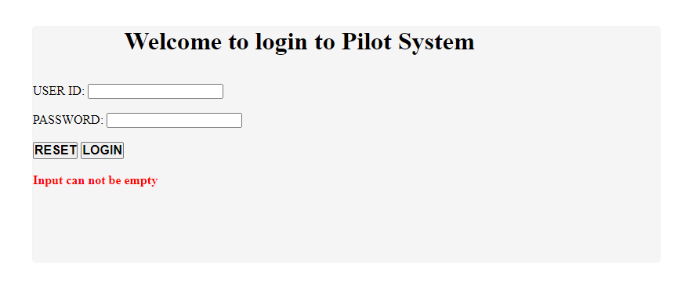

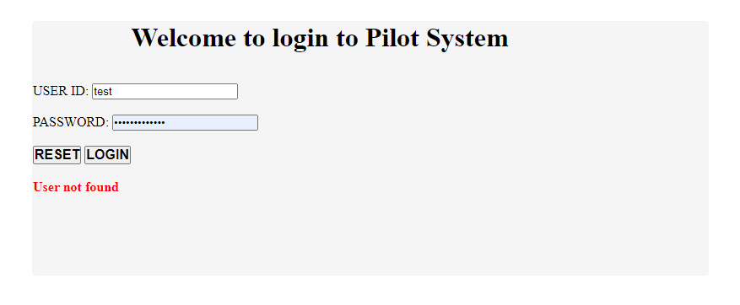

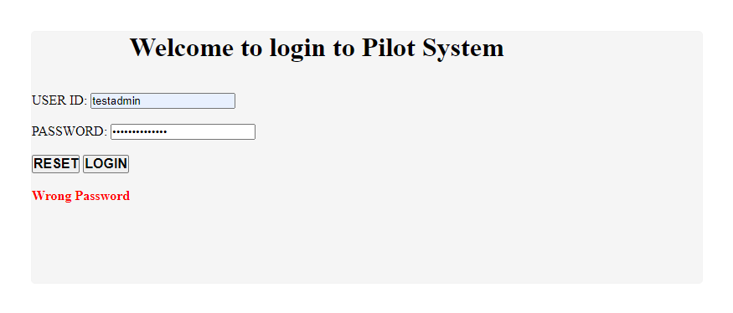

Case 2: User successed login

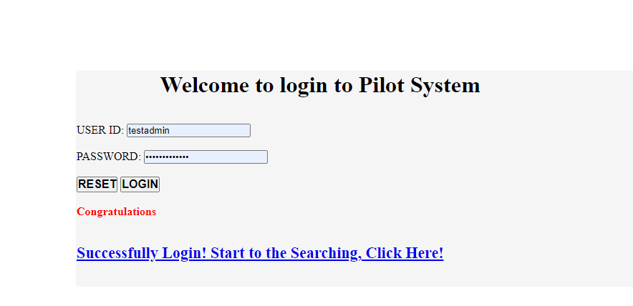

Note: In order to show case, change 10 data column to the year after 2012.

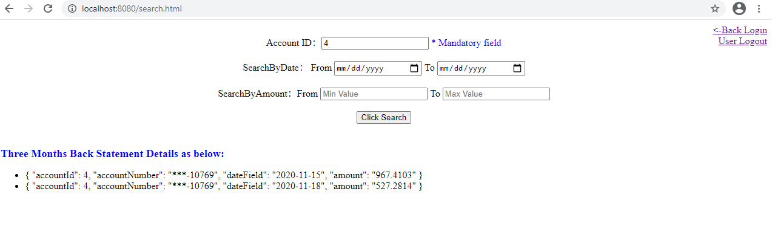

## - The request should specify the account id.

Case 1：account ID should not be empty.

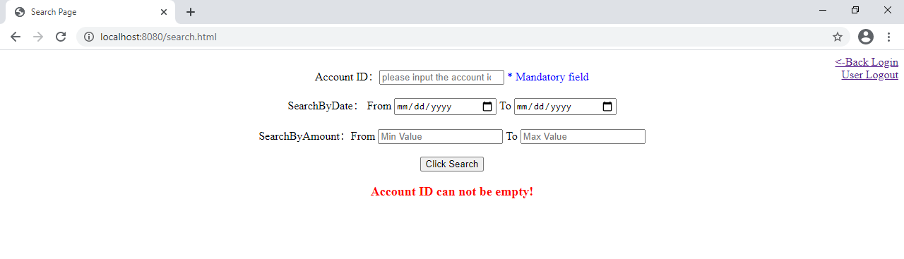Case 2: Input correct account ID:

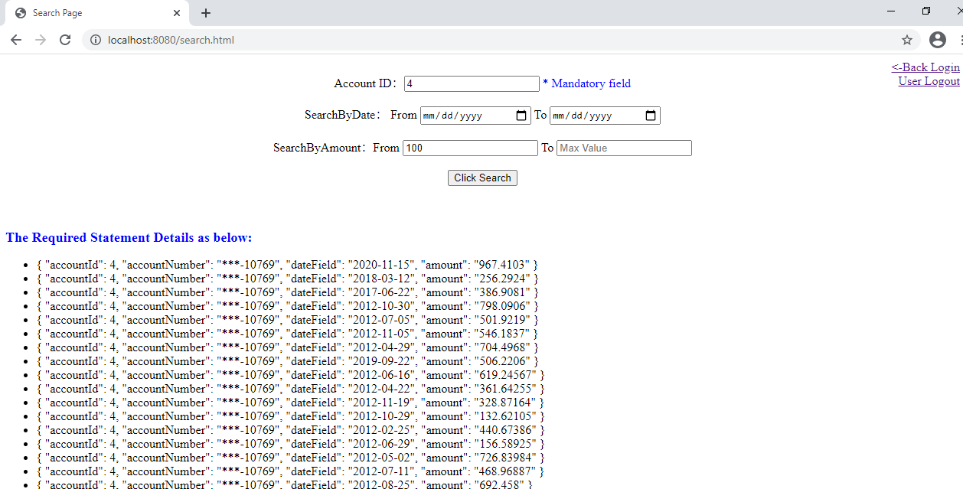

## - If the request does not specify any parameter then the search will return three months back statement.

Note: In order to test, has change some data to 2020 year.



## - If the parameters are invalid a proper error message should be sent to user.

## 

## - The request can specify from date and to date (the date range).

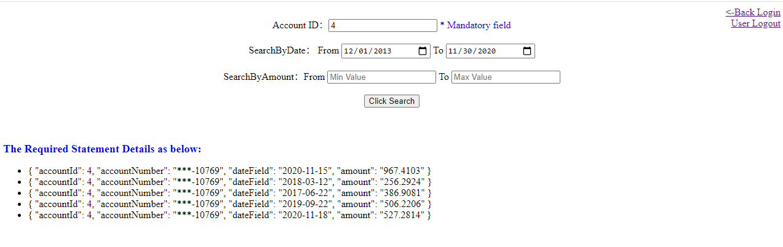

## - The request can specify from amount and to amount (the amount range).

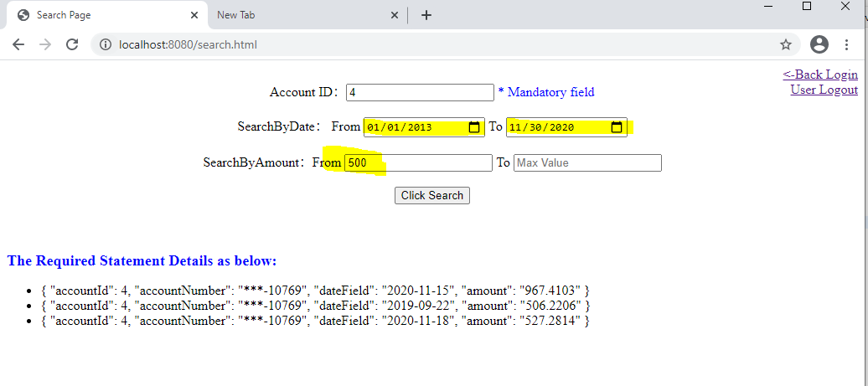

## - The account number should be hashed before sent to the user.

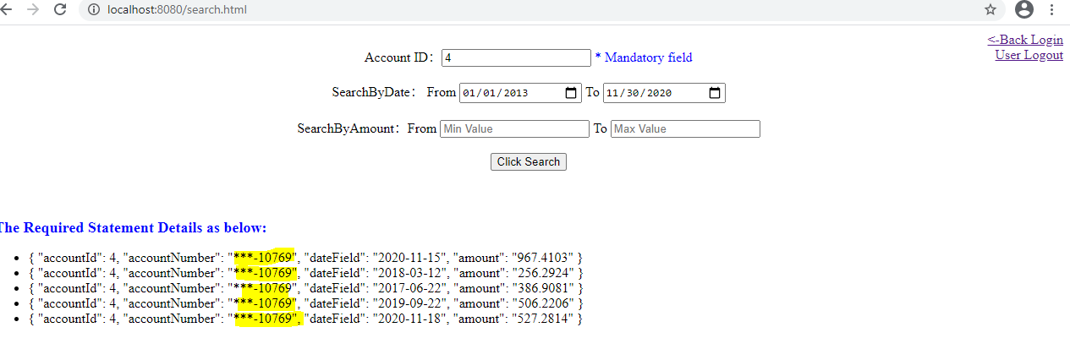

## - All the exceptions should be handled on the server properly.

The Relevant exceptions has been handle in the code as well.

## -The ‘testadmin’ user is able to perform all the requests (specify date and amount range).

Case 1：Range search for date and amount

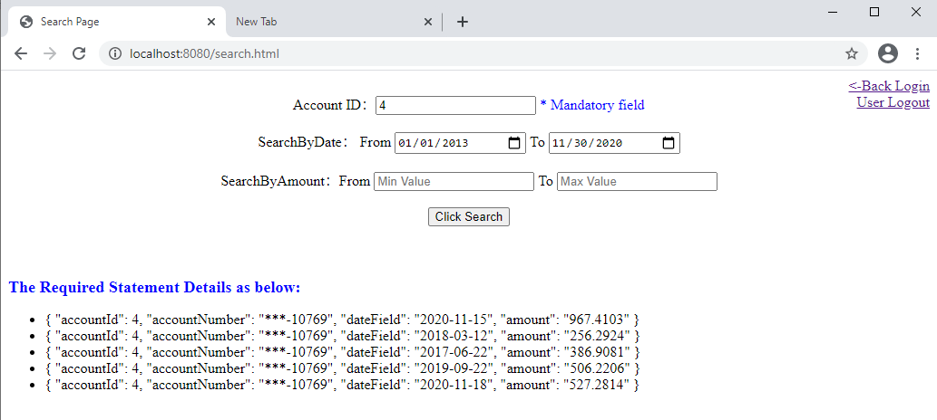

Case 2: Only Date search or Amount search.

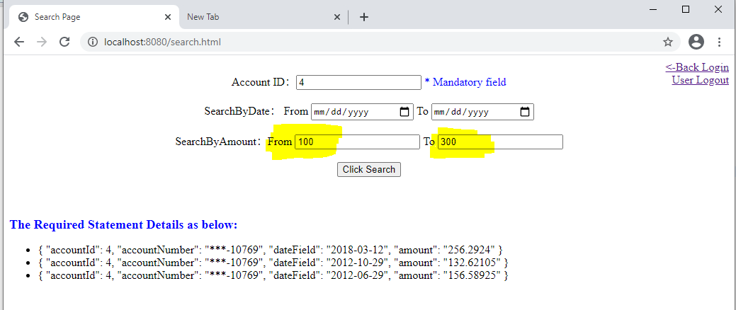

## - The ‘testUser’ can only do a request without parameters which will return the three months back statement.

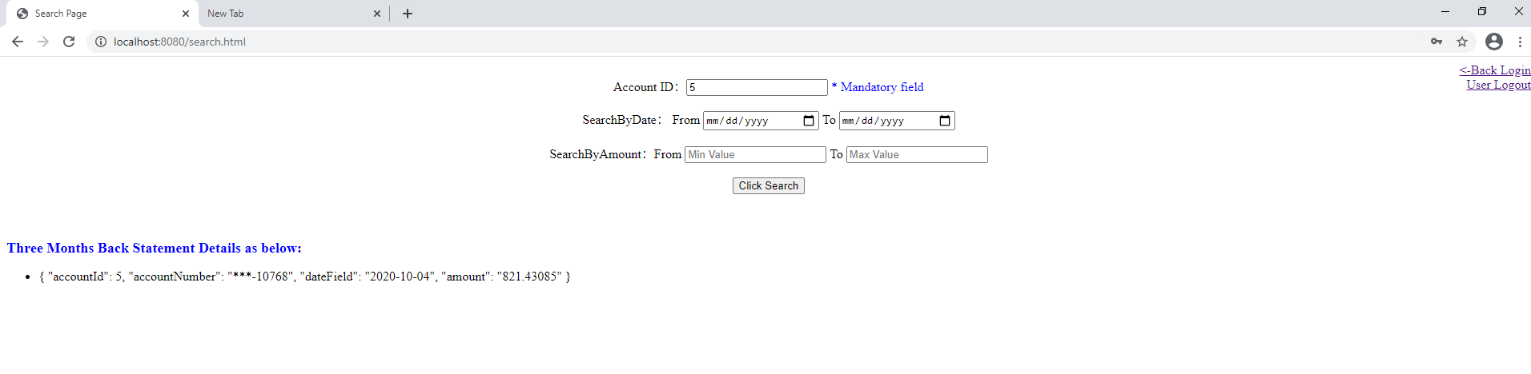

## - When the test user tries to specify any parameter, then HTTP unauthorized access error will be sent.

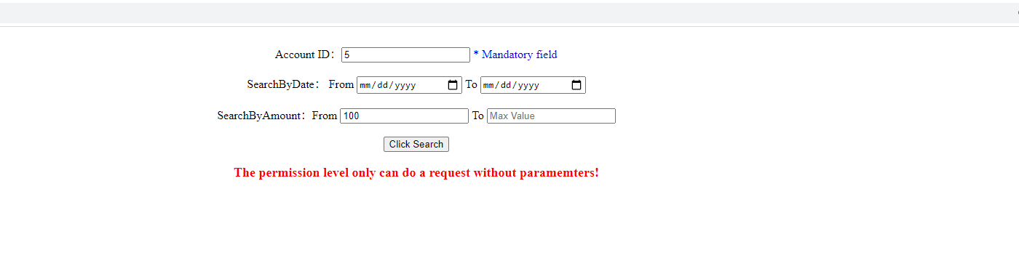

## - The session time out is 5 minutes.



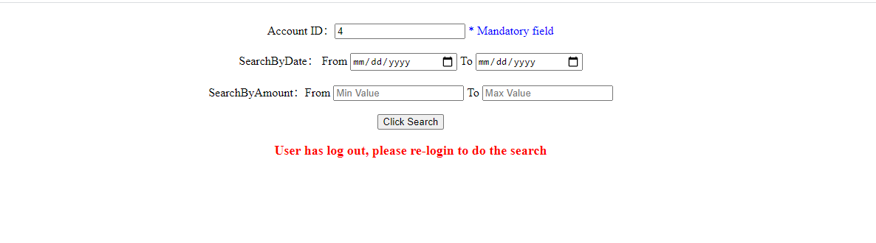

## - The user cannot login twice (the user should logout before login).

